Create a Glue Workflow with the Glue Crawler on S3 staging area, Glue Spark ETL Job and the Glue Python shell job created previously.

The starting trigger for this workflow is an EventBridge event. You can specify the number of events but not the name of the EventBridge rule. The integration of EventBridge rule to workflow is done in EventBridge, where, you mention the Glue workflow name to be triggered.

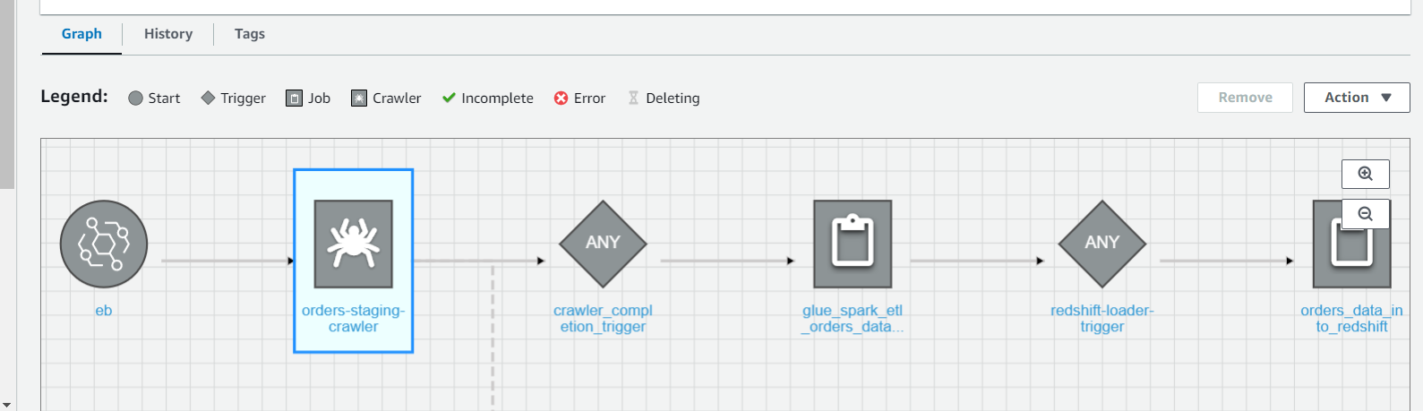

You will need 2 other triggers – one to start the Glue Spark ETL job after the completion of the crawler on S3 staging area (to load redshift staging area from S3 staging area with job bookmark enabled) and another trigger to start the Glue Python shell job after the completion of the Glue Spark ETL job (to load the final redshift table after performing enrichment / upsert).